DESIGN PATTERN AND PRINCIPLES:
Exercise 1: Implementing the Singleton Pattern
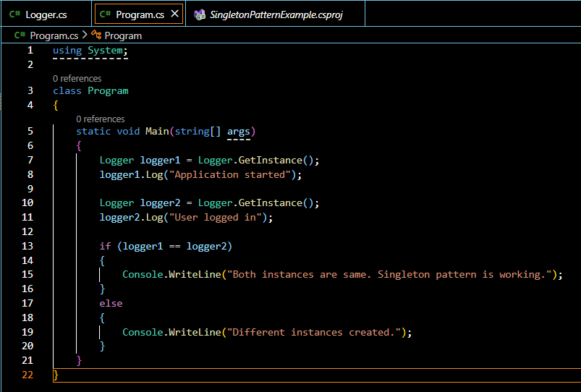
1.PROGRAM.CS

2

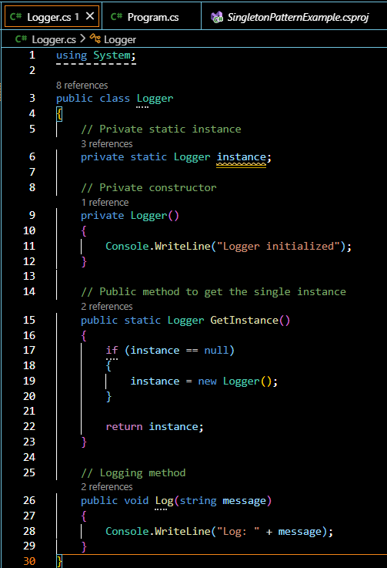
2.LOGGER.CS

OUTPUT:
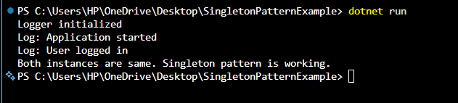

Exercise 2: Implementing the Factory Method Pattern
DocumentFactory.cs
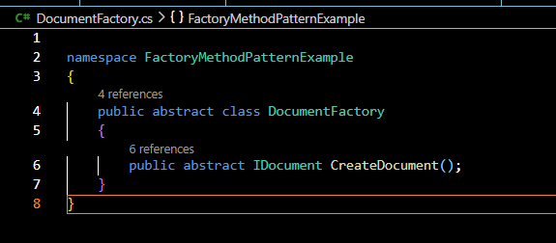
ExcelDocument.cs
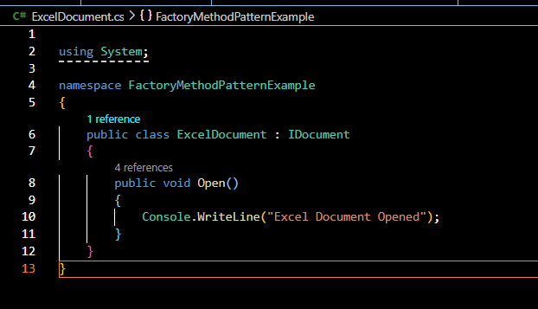

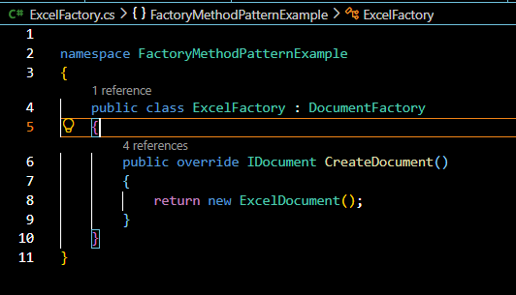
ExcelFactory.cs

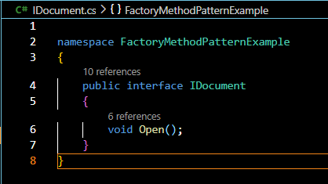
IDocument.cs

PdfDocument.cs
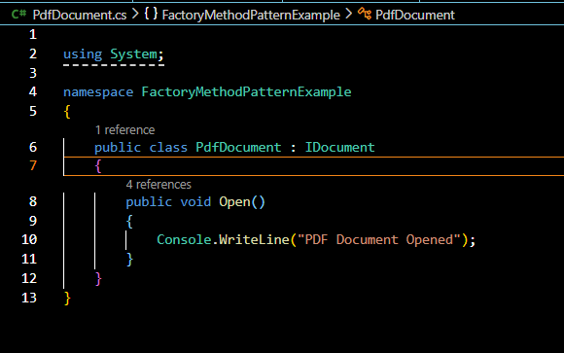

PdfFactory.cs
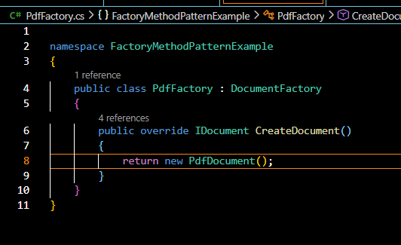
Program.cs
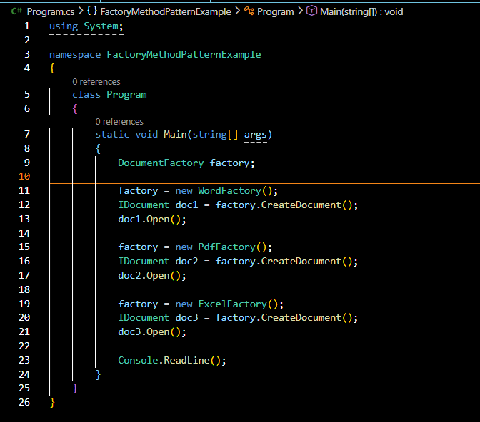

WordDocument.cs
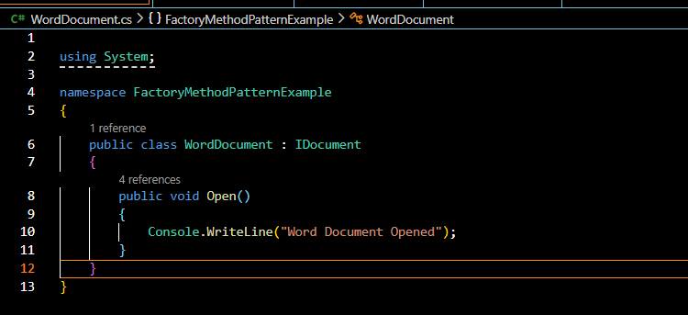
WordFactory.cs
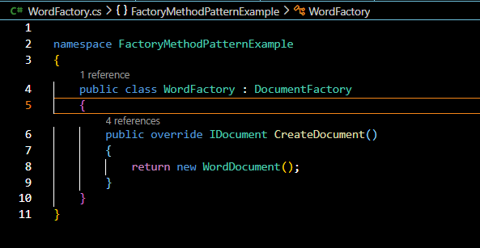
OUTPUT:
